**Victoria Rossi**

**THA3**

**Research question:**

What is the relationship between the number of family units and unaccompanied children apprehended crossing between Ports of Entry in the Laredo Field Office, and the number of family units and unaccompanied minors presenting themselves at Ports of Entry in the Laredo Field Office?

**Sources:**

1. **Variable: In Between POE**

Statistics for “In Between POE” variable were compiled from data sources titled “United States Border Patrol Southwest Family Unit Subject and Unaccompanied Alien Children Apprehensions Fiscal Year - By Month” for Fiscal Years 2016, 2017, 2018, and 2019. This is an example of what the tables look like:

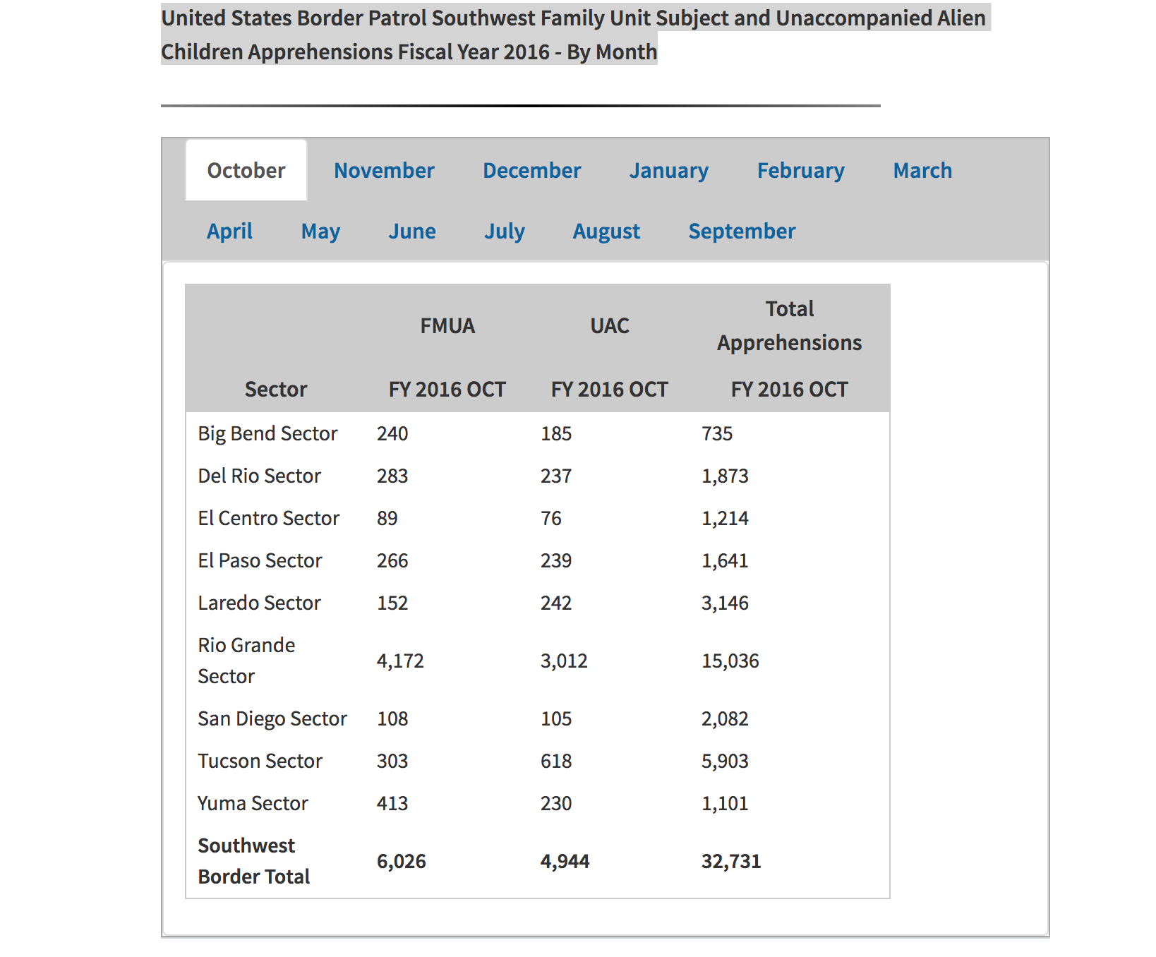

The following links will take you to the original data sources. Scroll down to the bottom of each page to find the tables. Once you find the tables, you will need to click on individual months to see the data by month.

2019

<https://www.cbp.gov/newsroom/stats/sw-border-migration/usbp-sw-border-apprehensions>

2018

<https://www.cbp.gov/newsroom/stats/usbp-sw-border-apprehensions>

2017

<https://www.cbp.gov/newsroom/stats/southwest-border-unaccompanied-children/fy-2016>

1. **Variable: At POE**

# Statistics for the “At POE” variable were compiled from data sources titled “Southwest Border Inadmissibles by Field Office” for Fiscal Years 2019, 2018, and 2017.

The following links will take you to the original data source:

2019

<https://www.cbp.gov/newsroom/stats/sw-border-migration/ofo-sw-border-inadmissibles>

# 2018

<https://www.cbp.gov/newsroom/stats/ofo-sw-border-inadmissibles>

# 2017

<https://www.cbp.gov/newsroom/stats/ofo-sw-border-inadmissibles-fy2017>